
FACULTY OF INFORMATION TECHNOLOGY
2025 DATABASES 600
ASSIGNMENT
richfield.ac.za

Name and Surname: Matthew Magadza
Student ITS No: 402310062
Qualification: BSCIT Year of Study: 2025 Semester: 1

Assignment due date: Date submitted
QUESTION | EXAMINER MARKS | MODERATOR MARKS | REMARKS
ASSIGNMENT INSTRUCTIONS
Please tick each box to confirm completion. (10 Marks)
Use Times New Roman font, size 12, with 1.5 line spacing throughout the document. Apply Harvard Referencing Style for all citations and references.
For essay-style assignments, please include the following sections:
Table of Contents Introduction
Main Body (with relevant subheadings) Conclusion
References
Submit the assignment in PDF format on Moodle. Use the specified cover page provided.
Include a signed declaration of originality.

DECLARATION OF ORIGINALITY:
I hereby declare that this assignment is my own work and has not been copied from any other source except where due acknowledgment is made. I affirm that all sources used have been properly cited and that this submission complies with the institution’s policies on academic integrity and plagiarism.
Student Signature: MTM Date:

Contents
Question 1 3
Question 2 3
2.1 Creating the Student Table 3
2.2 Inserting Given Data 4
2.3 Adding Custom Data 4
2.4 Updating a Student Surname 5
2.5 Renaming a Column 5
2.6 Deleting the Table and Database 6
Question 3 6
3.1 6
3.2 7
References 9

Question 1
Transitioning to a digital database Management System (DBMS) from a paper-based system will greatly improve how data is handled. Paper systems are slow, easy to lose, damage, and hard to organize (Watt,2022). A DBMS stores data digitally, offering a faster access, better security, and easy updates (Kumar,2025). The paper files will need to be found and sorted by hand while a DBMS uses digital tables which are easy and fast to search though (Kumar, 2025; Bergsteinsson, 2023). Paper records tend to be inconsistent and the DBMS will reduce errors with rules and keep the data safe by using passwords, user role such as admins, and developers, and general users (Nelson,2023; Watt, 2022; AgilitySytem,2023).Updating paper records takes time and requires more space than A DBMS which handles large amounts of data quickly and automatically backs up information (ScalableDB, 2024). The components we will need other than the users we will need computers and storage devices (InterviewBit, 2023) such as hard drives or solid state drives(SSD),software like MySQL SQL server and MangoDB which are examples of database engines and tools (Nelson, 2023) , We will store the data in tables and metadata (Marques, 2025), we have to create Guidelines for managing the DBMS (Nelson, 2023), and we will need to use a language like SQL to query from the DBMS (InterviewBit, 2023).The function of DBMS are Data Definition :Set up and change data structures (Marques, 2025). Data manipulation : adding, editing, or deleting data (Taylor, 2025). Data retrieval: though searching and queries efficiently (Marques, 2025).Administration: controlling access and managing backups (AgilitySystem, 2023).
The advantages of DBMS
- Accurate and consistent data (Kumar, 2025)
- Very secure (AgilitySystem, 2023)
- Quick access to the data (Taylor, 2025)
- Easy to scale (ScalableDB, 2024)
- Automatic backups and recovery (Marques, 2025)
The disadvantage of DBMS
- It is Expensive to install and maintain (Taylor, 2025)
- If extra features are added it may slow down (Marques, 2025)
- Needs regular updates (Nelson, 2023)

Question 2

2.1 Creating the Student Table
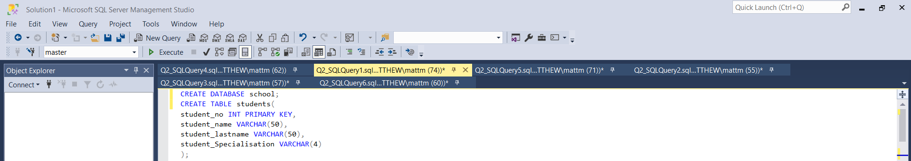
The CREATE TABLE command is used to define the structure of the students table with the 4 fields: a unique Student_Number, Student_Name, Student_Surname, and Student_Specialisation. The Student_Number is defined as the primary key, which ensures that each student record is uniquely identifiable (Coronel and Morris, 2019).
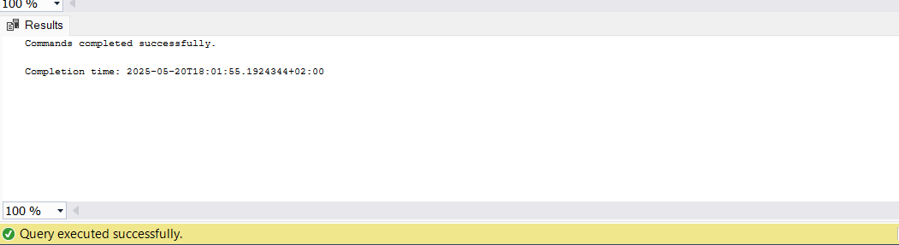

2.2 Inserting Given Data
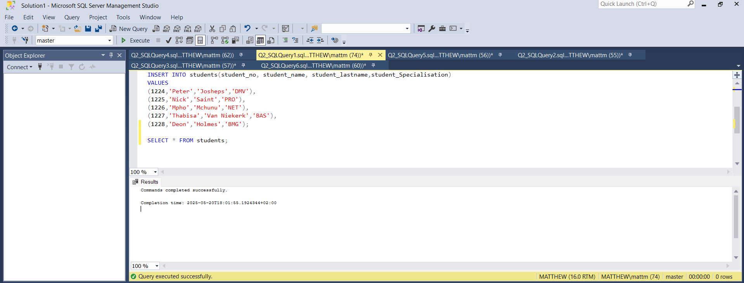

The INSERT INTO statement adds predefined data into the Student table. This populates the table with three initial student records (Oppel, 2011).

2.3 Adding Custom Data
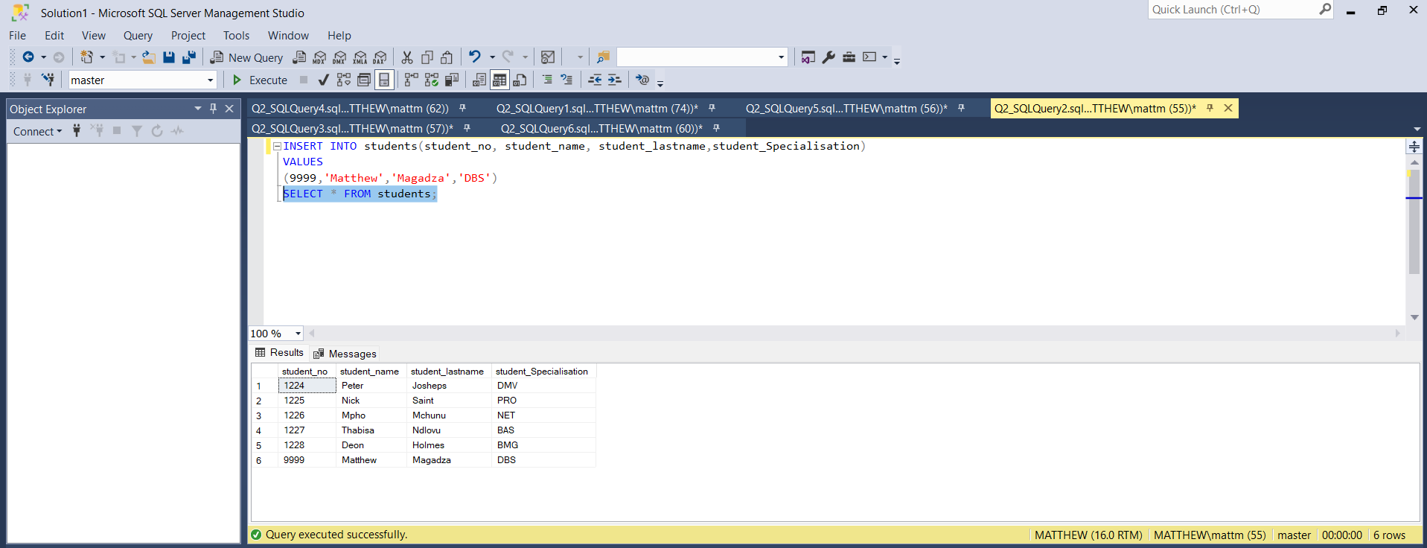

This step inserts a custom record with personal student information. It follows the same INSERT INTO structure and demonstrates how new data entries are added to an existing table (Rob, Coronel and Crockett, 2020).

2.4 Updating a Student Surname
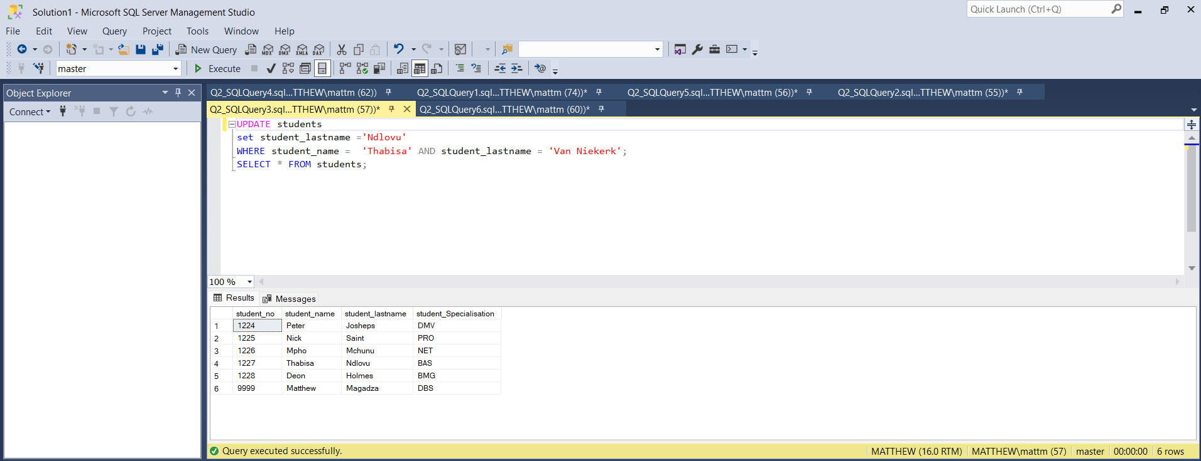

The UPDATE command modifies an existing record in the table. In this case, the surname of student Thabisa is changed from 'van Niekerk' to 'Ndlovu'. This operation highlights data correction within a DBMS (Date, 2012).

2.5 Renaming a Column
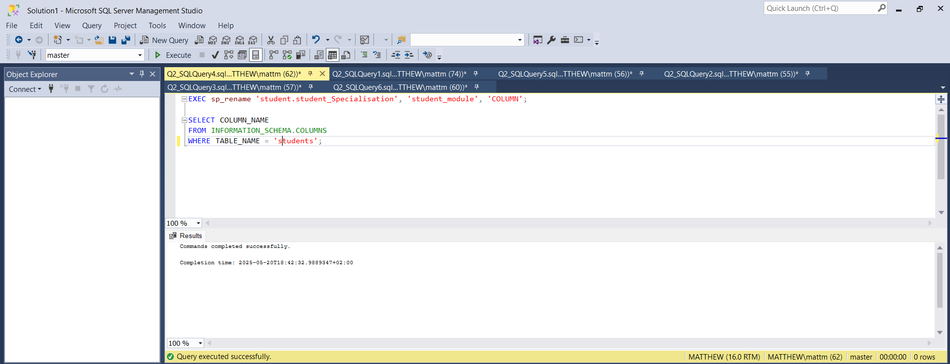
This SQL command uses the sp_rename stored procedure to rename a column. It changes Student_Specialisation to Student_Module, demonstrating how a DBMS allows for schema alterations without affecting the entire table (Kumar, 2025).

2.6 Deleting the Table and Database
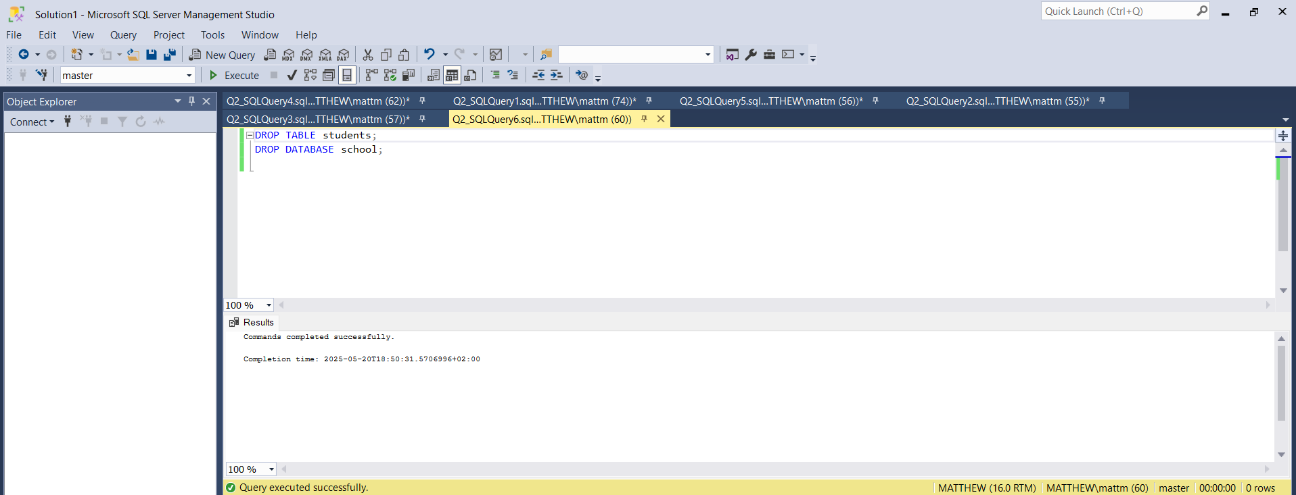
The DROP TABLE and DROP DATABASE commands are used to permanently remove the student table and the database it is stored in. These commands are powerful and should be used with caution as they erase all stored data (Coronel and Morris, 2019).

Question 3

3.1
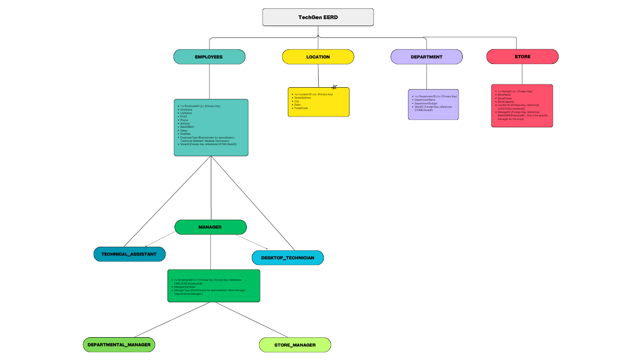

TechGen's business principles served as the foundation for the development of the EERD mentioned above. A store can have up to three departments and several staff, all connected to a single location. Technical Assistant and Desktop Technician are the two subcategories of the employee entity. Although they play two different roles—store manager and departmental manager—managers are also employees. Role classification is made simpler by the introduction of generalization hierarchies (Rob, Coronel, & Crockett: 2020).

3.2
Given Report the table below

STUD_NO | STUD_NAME | STUD_SNAME | QUAL_ID | QUAL-DESC | FINAL_PROJ | PROJ_NAME
1125 | Marco | Polo | 1 | Degree, Undergrad | Required | 3rd Year Project
5541 | Jason | Statham | 2 | Higher Certificate | Not Required
6687 | Ben | Grimm | 1 | Degree, Undergrad | Required | 3rd Year Project
2551 | Peter | Parker | 3 | Diploma | Required | 3rd Year Project
6669 | Thando | Wolff | 5 | Honours | Required | Research project
8879 | Theodore | Jacobs | 8 | MBA | Optional

Step-by-Step Normalisation
Unnormalised Form (UNF)
The initial report contains redundant and repeating data and is therefore not suitable for efficient database use.

First Normal Form (1NF)
1NF requires that all attribute values are atomic and that each record is unique. The report already satisfies this condition.

Second Normal Form (2NF)
To achieve 2NF, we remove partial dependencies (when a non-key attribute depends on part of a composite primary key).
Student Table

STUD_NO | STUD_NAME | STUD_SNAME | QUAL_ID
1125 | Marco | Polo | 1
5541 | Jason | Statham | 2
6687 | Ben | Grimm | 1
2551 | Peter | Parker | 3
6669 | Thando | Wolff | 5
8879 | Theodore | Jacobs | 8

Qualification Table
QUAL_ID | QUAL_DESC
1 | Degree, Undergrad
2 | Higher Certificate
3 | Diploma
5 | Honours
8 | MBA

Third Normal Form (3NF)
We remove transitive dependencies (when non-key attributes depend on other non-key attributes).

FINAL_PROJ and PROJ_NAME depend on QUAL_ID, not directly on STUD_NO.
Project Table
QUAL_ID | FINAL_PROJ | PROJ_NAME
1 | Required | 3rd Year Project
2 | Not Required | NULL
3 | Required | 3rd Year Project
5 | Required | Research project
8 | Optional | NULL

Boyce-Codd Normal Form (BCNF)
A table is in BCNF if every determinant is a candidate key. Each of our resulting tables meets this condition:
- In Student, the primary key is STUD_NO
- In Qualification, the primary key is QUAL_ID
- In Project, the primary key is QUAL_ID
Therefore, all relations are in BCNF.
Final Tables in BCNF
Student
| STUD_NO | STUD_NAME | STUD_SNAME | QUAL_ID |
Qualification
| QUAL_ID | QUAL_DESC |
Project
| QUAL_ID | FINAL_PROJ | PROJ_NAME |

Explanation
The original report had transitive and partial dependencies that made it inefficient and inconsistent in a relational database environment. By applying the normalisation process up to BCNF, the data was broken down into three relations—Student, Qualification, and Project. Each table now holds attributes that depend only on the primary key, and all functional dependencies are properly resolved (Date, 2012; Coronel and Morris, 2019).

References
- AgilitySystem (2023) Electronic Document Management System Or Paper-Based. Available at: https://www.agilitysystem.net/insight/edms-vs-paper-based-systems (Accessed: 20 May 2025).
- Bergsteinsson, J. (2023) ‘Electronic Data Capture Systems vs. Paper-based Data Collection’, Greenlight Guru, 24 March. Available at: https://www.greenlight.guru/blog/electronic-data-capture-edc-system-vs-paper (Accessed: 20 May 2025).
- Coronel, C. and Morris, S. (2019) Database Systems: Design, Implementation, & Management. 13th edn. Boston: Cengage Learning.
- Date, C.J. (2012) An Introduction to Database Systems. 8th edn. Boston: Pearson.
- InterviewBit (2023) What are the Components of DBMS (Database Management System)?. Available at: https://www.interviewbit.com/blog/components-of-dbms/ (Accessed: 20 May 2025).
- Kumar, A. (2025) Difference Between File System and DBMS. GeeksforGeeks. Available at: https://www.geeksforgeeks.org/difference-between-file-system-and-dbms/ (Accessed: 20 May 2025).
- Marques, L. (2025) Structure of Database Management System. GeeksforGeeks. Available at: https://www.geeksforgeeks.org/structure-of-database-management-system/ (Accessed: 20 May 2025).
- Nelson, T. (2023) Components of DBMS. Tutorialspoint. Available at: https://www.tutorialspoint.com/what-are-the-components-of-dbms (Accessed: 20 May 2025).
- Oppel, A.J. (2011) Databases: A Beginner’s Guide. 2nd edn. New York: McGraw-Hill.
- Rob, P., Coronel, C. and Crockett, K. (2020) Database Systems: Design, Implementation, & Management. 13th edn. Boston: Cengage Learning.
- ScalableDB (2024) DBMS Architecture: Components and Types of Database Models. Sprinkle Data. Available at: https://www.sprinkledata.com/blogs/dbms-architecture-its-5-key-components-and-types-of-database-models (Accessed: 20 May 2025).
- Taylor, R. (2025) Relational database. Wikipedia. Available at: https://en.wikipedia.org/wiki/Relational_database (Accessed: 20 May 2025).
- Watt, P. (2022) The Difference between Electronic and Paper Documents. The George Washington University. Available at: https://www2.seas.gwu.edu/~shmuel/WORK/Differences/The%20Difference%20between%20Electronic%20and%20Paper%20Documents.html (Accessed: 20 May 2025).

